Lab – Reporting
Directions: Evaluate different types of reports. Use AI to create the reports and view the output as if a third-party vendor produced them.

Ethan Perdieu
Generate AI Reports
- Use AI tool of your choice and produce the three reports below. Do not clean up or fix the reports manually. Only use one refinement prompt per report. Use the full report output.
  - Penetration testing report
    - Mid-sized company, remediation recommendations
  - SOC 2 report
    - 12-month review period, cloud-based company
    - Trust services criteria for security and availability only
  - ISO 27001 report
    - Company has already ISMS aligned with ISO/IEC 27001:2022
    - Summary of annex A

- Provide the prompt used for creating each report.

Penetration Testing Report Prompt
Generate a professional penetration testing report for a mid-sized company. Include an executive summary, scope and methodology, findings with severity ratings (critical, high, medium, low), evidence/observations for each finding, and remediation recommendations. Use realistic but fictional company and system names

SOC 2 Report Prompt
Generate a SOC 2 Type II report for a cloud-based company covering a 12-month review period. Include only the Trust Services Criteria for Security (CC series) and Availability (A series). Include an auditor's opinion section, management's assertion, description of the system, and criteria with corresponding controls tested and results.

ISO 27001 Report Prompt

Generate an ISO 27001 audit report for a company whose ISMS is already aligned with ISO/IEC 27001:2022. Include an executive summary, audit scope and objectives, audit findings by domain, a summary of Annex A controls covering all control categories, and an overall conclusion.

Evaluate Reports
Rate each report using Low/Med/High or a Likert scale of (1-5).
Claude Penetration Testing Report using Sonnet 4.6 – High (4)
- Report general information
Report Type – Penetration Testing for external and internal infrastructure and web application

Intended Audience – Primary audience is the security team and CISO at Meridian FinTech Solutions. The executive summary is for C-suite.

Intended Use – Risk identification and remediation

- Structural correctness
  - Does it resemble a real report of this type?
Very much so. It follows the standard structure by professional testing. It starts with a cover page, then executive summary, scope & methodology, findings ordered by severity and then finally the appendix.
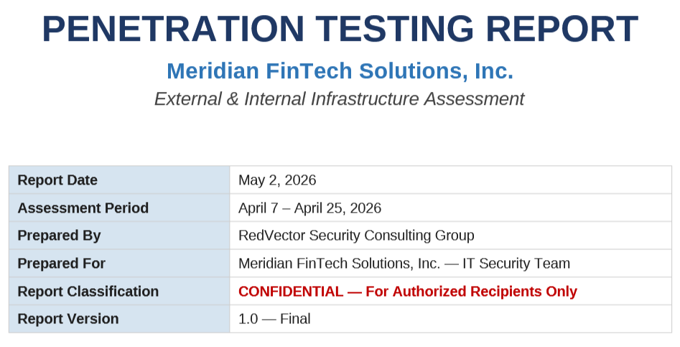

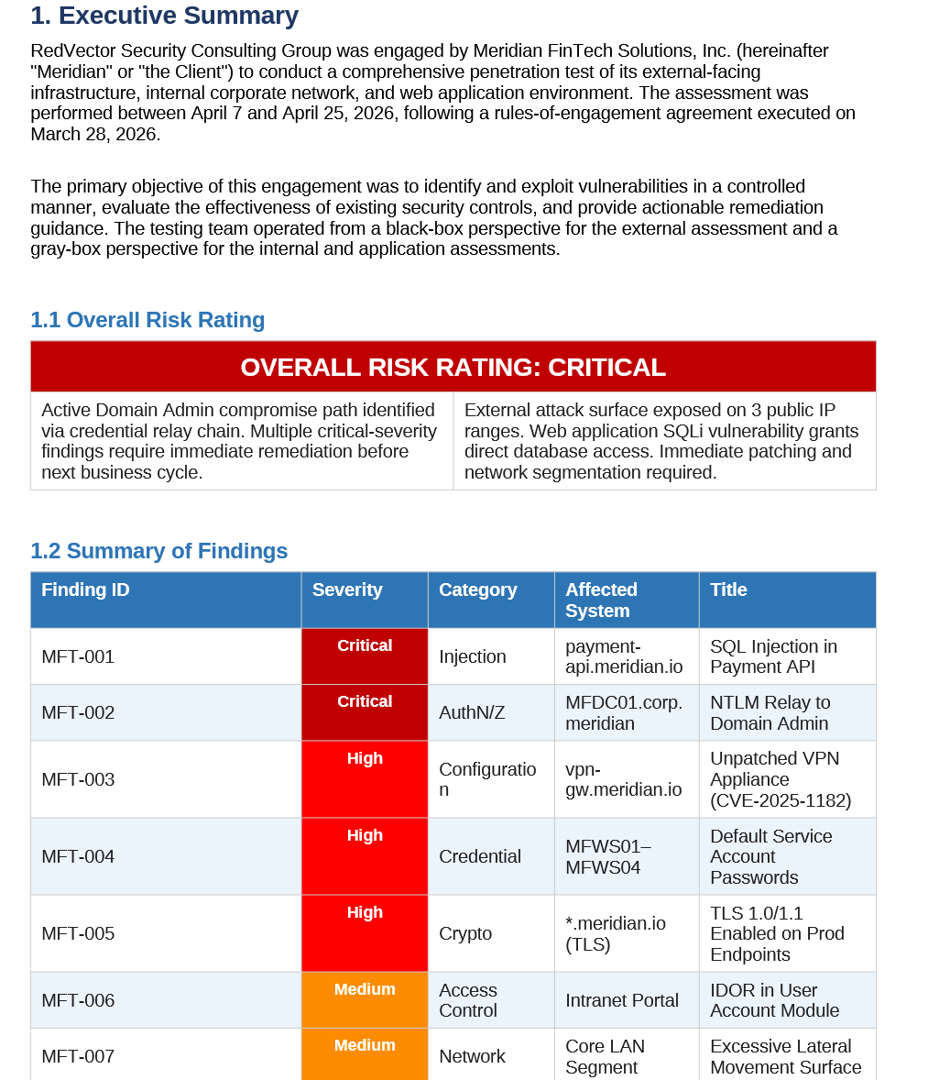
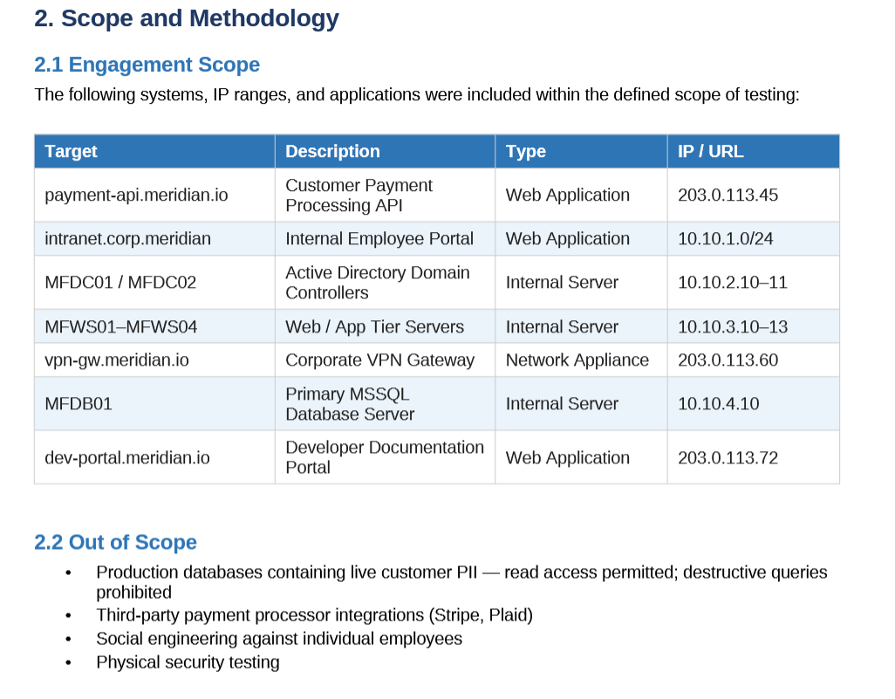

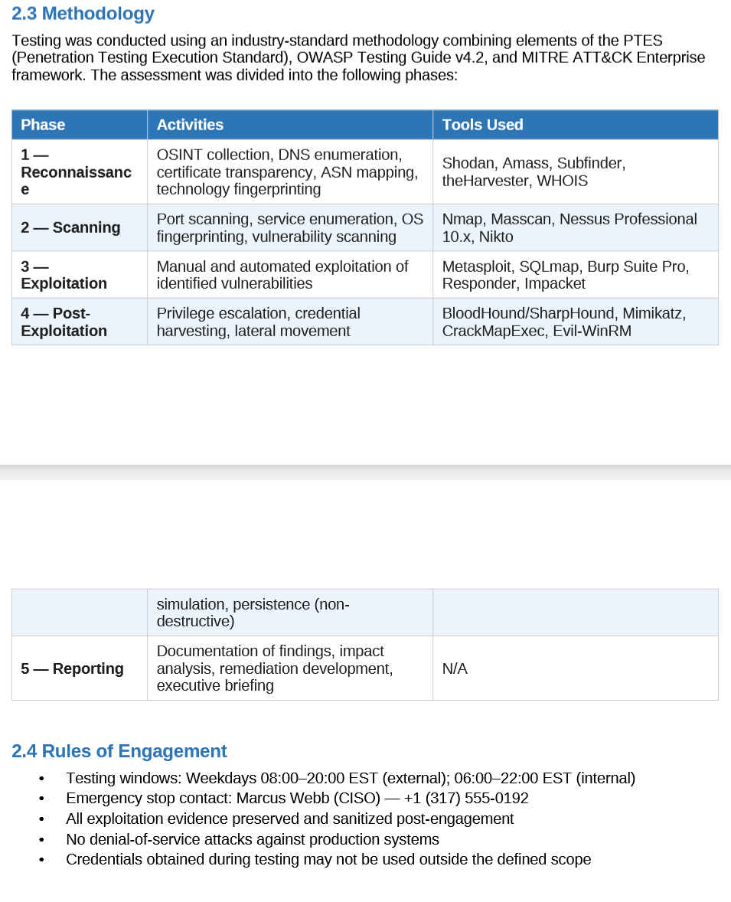
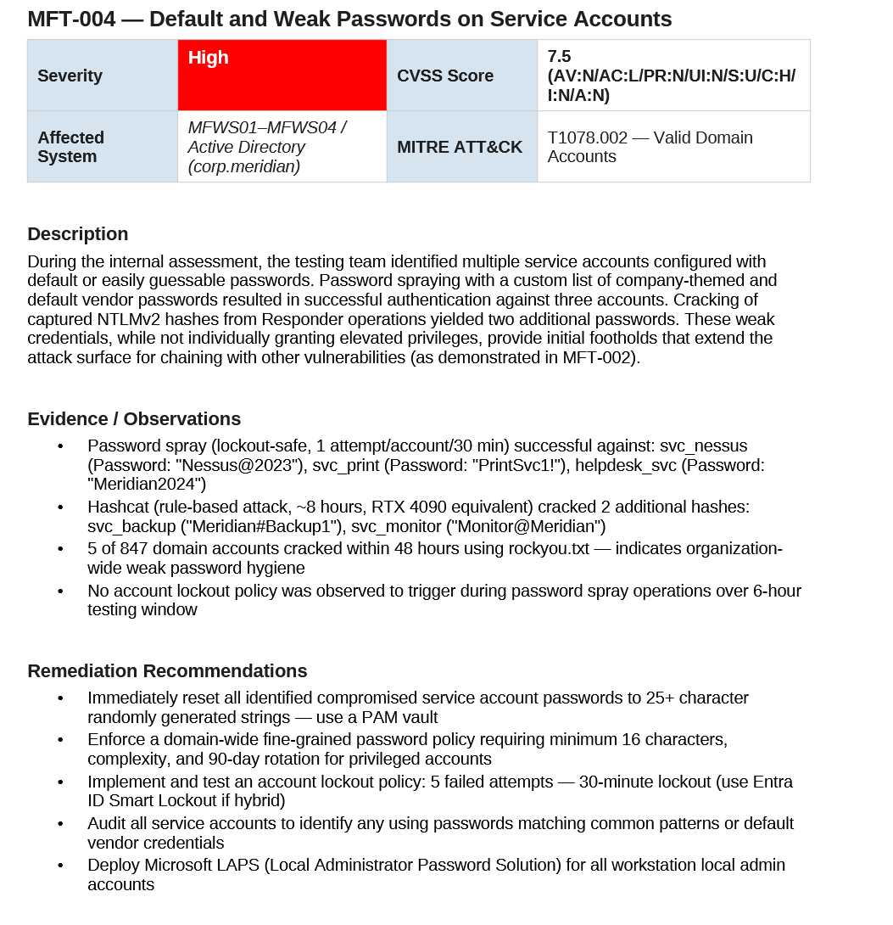

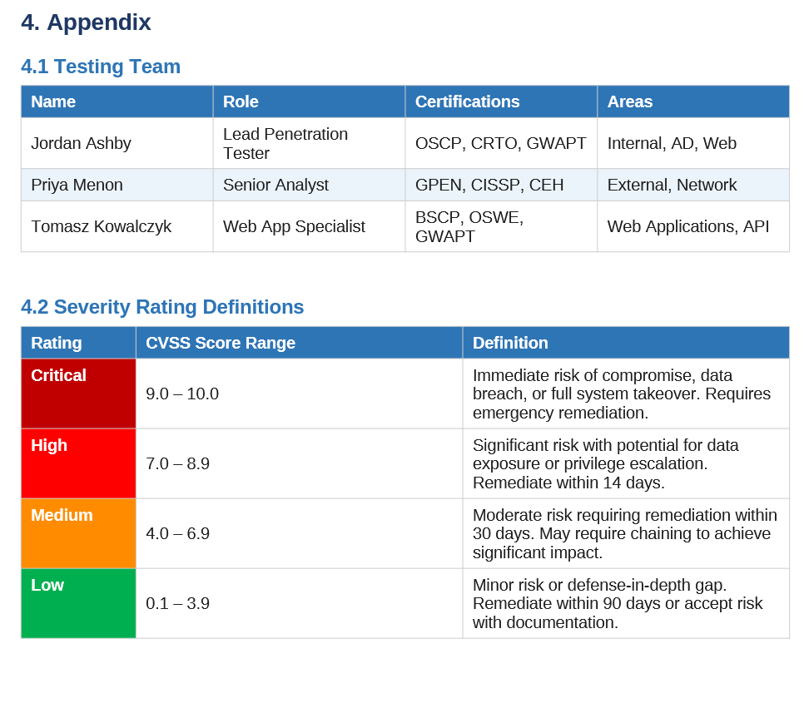
- Audience appropriateness
  - The report focuses on two audiences. The executive summary clearly shows the risk using color-coding and non-technical terms. The findings section then goes more in-depth for each risk which would be helpful for the security team and CISO.

- Control / methodology accuracy
  - The methodology uses the OWASP Testing Guide v4.2 and the MITRE ATT&CK Enterprise. These are both commonly cited in real engagements. Claude also used PTES. They broke it into 5 phases; Reconnaissance, Scanning, Exploitation, Post-Exploitation and reporting which aligns with how professional pen testing firms organize their documentation.

- Specificity vs generic language
  - I would say this is where the report shines the most. Instead of using generic terms like “SQL Injection was found” it actually gives parameters and flags along with them. It uses exact SQLmap flags, specific database names, timings, Event IDs, hash cracking specifics such as rockyou.txt and exact vulnerable parameters and the HTTP methods. The level of detail makes this pentest actionable rather than just pointing out the issues.

- Risk communication quality
  - This is another portion that Claude did insanely well. The CVSS scores seem accurate throughout the entire report. The critical ratings were justified and provided great insight into why it was given that risk rating. The findings section are also ordered by severity so the security team can tackle the most critical risks first. The remediation tactics are specific enough and actionable. The one thing that could be helpful is a roadmap or timeline of a plan that can be implemented.

- Red flags or hallucinations
  - No guarantees were made in the report but instead CVEs were listed along with remediation techniques. The scope section excludes any hallucinations. I did prompt them to give semi-real names.

- Overall professional credibility
  - I think this would pass initial review by a security professional. Credibility through real world applications proves that the material is credible. Along with the PCI DSS 4.0 Requirement references and other recommendations made throughout the report.

Evaluate Reports
Gemini ISO 27001 Report using Gemini 3 (Thinking) – Low (1)
Rate each report using Low/Med/High or a Likert scale of (1-5).
- Report general information
  - Report type: ISO 27001:2022 ISMS audit
  - Intended Audience: Unclear, the report does not identify whether it is for management, security team or users
  - Intended Use: Certification/recertification?
  - The report initially looks weak. Real reports establish audit type, lead auditor, intended audience and an opening section which isn’t there.

- Structural correctness
  - No, this is one of the biggest failures from Gemini. The audit should require a better scope, audit team identification, real findings, Annex A control assessment and certification recommendations. Gemini is closer to a one-page summary rather than a real report format.
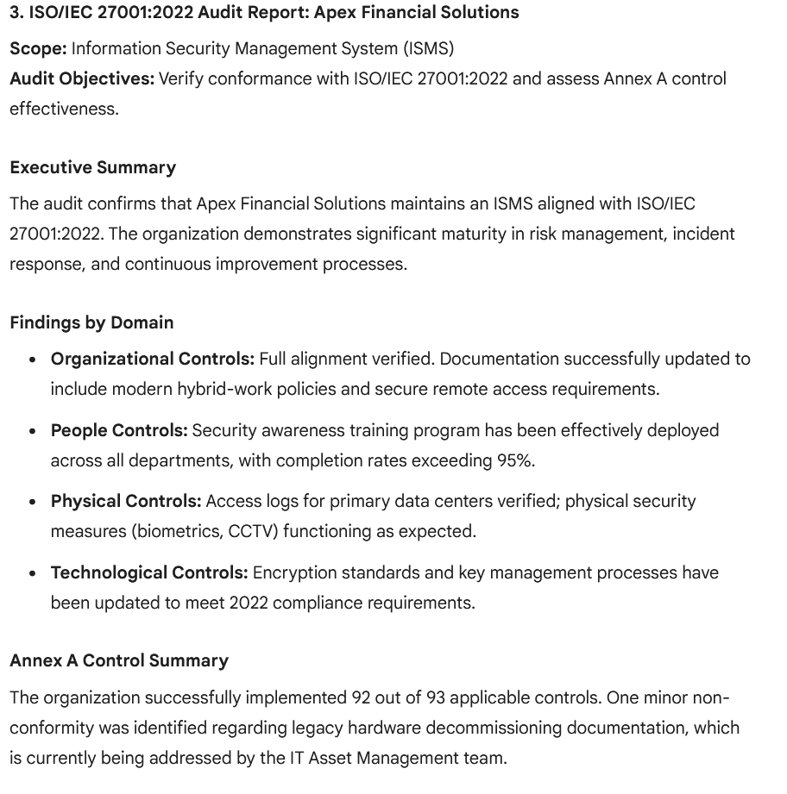

- Audience appropriateness
  - The language uses very generic terms and is more like a press release rather than an audit report. They use a lot of vague terms like “significant maturity” without any real explanation to what that could mean. They also do not serve multiple audiences; it is focused on just summarizing those real actionable steps.

- Control / methodology accuracy
  - No methodology is present at all. There are no references to ISO, audit criteria, samplings, or any other distinctions expected. The ISMS vs Annex A distinction was never made which are crucial to ISO reports.

- Specificity vs generic language
  - No, everything used is generic. They use terms like “Full alignment verified” without explaining how they verified it. “Completion rates exceeding 95%” for what training? There are no evidence descriptions anywhere within the report and no system names, or sample sizes.

- Risk communication quality
  - The only risk content displayed is one sentence about nonconformity regarding legacy hardware. It is still vague and provides no description of what is missing and no impact on action deadlines.

- Red flags or hallucinations
  - The conclusion states that the organization is “recommended for continued certification” which implies surveillance did occur. However, it is not mentioned in the report at all. Along with the claim of “92 out of 93 applicable controls” were implemented without and documentation.

- Overall professional credibility
  - No, this report would not pass initial review by an ISO lead. It lacks the fundamental components of a report and looks like an AI generated summary of what an ISO report should contain rather than a real report. Overall, it identifies the right generalized topics but does not go into depth at all and leaves significant gaps.

Evaluate Reports
ChatGPT SOC II Type II Report (2)
Rate each report using Low/Med/High or a Likert scale of (1-5).
- Report general information
  - Report Type: SOC 2 Type II – Security and Availability
  - Audience – Partially identified, user and auditors were implied but never fully stated
  - Use – Vendor assurance and compliance demonstration
  - The review timing, company name and auditor are present which are needed for reports. However, the report never identifies restrictions which SOC 2 requires. The report also does not state who the real report is for.

- Structural correctness
  - Kind of, a real SOC 2 requires four sections, Independent Service Auditor’s Report, Management Assertion, Description of the System and Criteria, Controls, Tests and results. These were only partially present throughout the entire report.
  - The structure exists but each section is vague. There is no details or information that describes how the system works.
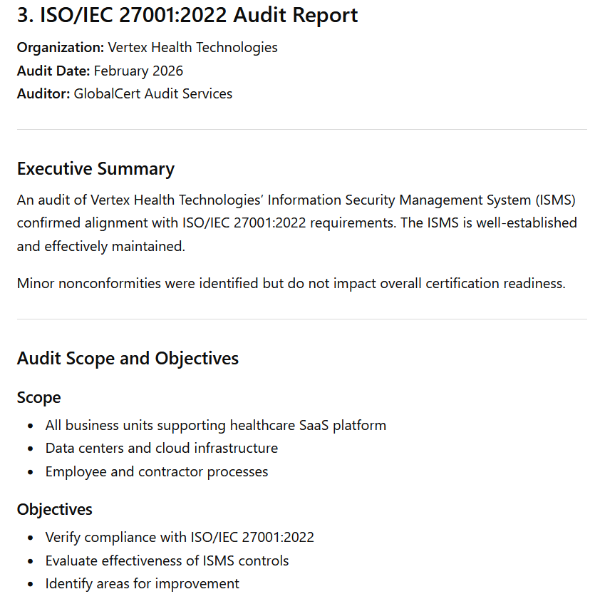

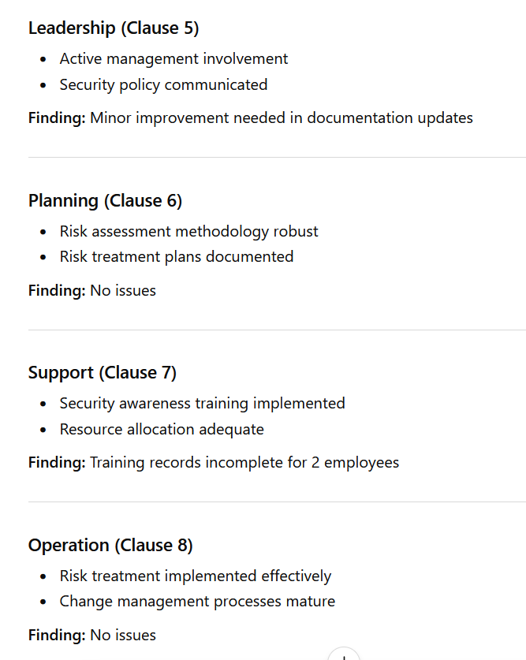
- Audience appropriateness
  - SOC 2 reports are for a specific audience that should be specified, which was not in this report. This is more of a checklist rather than a report and phrases like “operating effectively” were used without any evidence of that occurring.

- Control / methodology accuracy
  - This is one of ChatGPT’s biggest failures when creating the SOC 2 report. The auditor must describe the testing procedures, what was sampled, and what evidence was inspected, which was not in the report at all. In particular, they never went into how MFA was enforced or how they tested it.

- Specificity vs generic language
  - The control descriptions were very short and created more questions than they answered. They never referenced specific frameworks or policies or even the risks. ChatGPT uses generic terms like “AWS infrastructure” but never goes into depth of what that infrastructure entails. They also say “28 controls tested” but never list any of the 28 controls. They only list 11.

- Risk communication quality
  - SOC 2 reports communicate risk quality however this is not present in the report. A real SOC 2 auditor would provide explanation to the exceptions, and how they are tied to specific control IDs. The summary just says “3 exceptions” without and reasoning to what those may be.

- Red flags or hallucinations
  - Both the A2 and A3 criteria are not listed. The availability category is spoken about but is very vague. It also created fake criteria numbers and provided no real reasoning behind them.

- Overall professional credibility
  - No, this would not pass a professional credibility test at all. The missing A2 and A3 criteria is a major issue along with the vagueness of the entire document. Compared to a real SOC 2 report sample found online, it is missing that substance.

Report Comparison
Possible areas to review in reports: structure, depth, accuracy, references, terminology… etc.

- Which AI generated report was the best? Explain.

Claude easily generated the best reports overall because of both the formatting and material within it. The gap between Claude and every other report type was very large because of how in-depth and real-world applications Claude uses. The structure followed real report types, including evidence descriptions, tool names and sample sizes. It also provided correct terminology and referenced real OWASP testing guides and frameworks. The formatting was also well done and ready to be exported to a word document which wasn’t the case with the other models.

- Which AI generated report was the worst? Explain.

I would say the world AI generated report was the Gemini ISO report. The entire report fit on a single page while real ISO reports require findings, auditor identification, audit type among a plethora of other things. None of that was present in a meaningful way in the Gemini Report. Every finding was a single vague sentence without real controls. The report stated “92 out of 93 applicable controls” but failed to reference any document for them. There was also no methodology section and only really had correct headers. It reads more like a summary of an ISO report rather than a real audit report.

References

https://www.iso.org/obp/ui/en/#iso:std:iso-iec:17021:-1:ed-1:v1:en

https://anab.ansi.org/standard/iso-iec-17021-1/

http://www.pentest-standard.org/index.php/Main_Page

http://www.pentest-standard.org/index.php/Pre-engagement

https://pentest-standard.readthedocs.io/en/latest/tree.html

